Mask or not Mask?

# ABSTRACT

As vaccines become available, states started to roll back COVID restrictions including mask mandates. Around September, more and more schools decided to go back to in-person or at least hybrid instruction. The reopen of campus is a major source of mobility change during this period, which coupled with virus variation, questions the validation of a loose public policy on masking. This study aims to evaluate the effectiveness of public mask mandate policy. A causal inference framework, together with three different approaches including outcome regression, propensity score weighting and doubly robust estimate is applied to estimate the average causal effect of having a mask mandate implemented at least for the non-vaccinated by September 1, 2021, on COVID confirmed case growth rate. The result shows mask mandate implementation will lead to a 0.537% reduction in growth rate 14 days after the target date. Moreover, the mask mandate will have long-term benefit in health outcomes that the difference in expected growth rate between treatment and control group increases as time goes by.

**Keywords:** Mask Mandate, Confirmed Case Growth Rate, Causal Inference

**Contents**

ABSTRACT 1

INRODUCTION 3

LITERATRUE REVIEW 3

METHODOLOGY 4

DATA 5

RESULT 7

Outcome Model 7

Propensity Score Weighting 8

Doubly Robust Estimator 12

Comparison of Results 13

DISCUSSION 15

REFERENCE 16

# INRODUCTION

The onset of pandemic has resulted in near 50M confirmed cases causes and 800 thousand deaths by December 11th, 2021. To mitigate the impact, orders, and measures such as shelter-in-place restriction, closure of business, social distancing and mask mandate has been implemented by the government throughout the past two years.

As vaccine became available and a flatten trend was observed. By March 2021, the daily number of new infections had steeply declined, and April through June saw those numbers go down even further (1). More and more states started to loosen statewide pandemic restrictions like indoor capacity limits and mask mandates. However, in July, another surge in cases of COVID-19 raised the concern for public health again. The arrival and spread of delta coronavirus variant not only challenged the effectiveness of vaccine but also put the political correctness of lifting restrictions into question. Take mask mandate as an example. Some states like Ohio at present have no guidance on mask mandate; some like Texas even ban mask mandate; some have statewide recommendation but is not enforced. The potential problem with the ease on mandate is that, first, despite of the increased vaccination rate, the vaccine is not as effective to the new variant as it was to the original virus; and second, even if it were, the non-vaccinated is still vulnerable and in fact, more vulnerable to the variant. Lifting the mask mandate could potentially speed up the virus circulation among the non-vaccinated, extend to the vaccinated and thus the whole population.

# LITERATRUE REVIEW

Previous studies used different approaches to analyze the effectiveness of implementing mask mandate. For example, Lyu & Wehby (2) used difference-in-difference method to examine the different strictness of public masking policies on daily growth rate, which is defined as the natural log of total cases in a day minus the log of total cases in previous day. Chernozhukov et al. (3) examined the implementation of employee face masking mandates using linear structural equations. Wong (4) used a doubly robust approach with targeted maximum likelihood estimation using Super Learner to examine the impact of early versus delayed implementation of state-level public masking orders subsequent COVID-19 growth rates. Early implementation is defined as having a state-level mandate in place before September 1, 2020, the approximate start of the school year. And the COVID-19 growth rates are defined as the relative increase in confirmed cases X days after September 1.

Wong et al. shows similar concerns of mask policy on covid growth rate during the school year. However, in 2020, the mobility change is not that great because many schools adopted the online format. Whereas in 2021, as the state reopen, most of the schools return to in-person instruction around September 1. Not only students but also their parents have the tendency to increase the frequency of their daily outdoor activities and travel, which could potentially lead to a higher exposure rate and thus a higher infection risk. At the moment, having a right policy implemented is thus especially critical. Therefore, accounting for the critical role of the non-vaccinated in this battle, our study aims to analyze the effect of mask mandate implementation at least for the non-vaccinated on COVID-19 growth rate during the critical period when mobility increases.

# METHODOLOGY

The causal inference analysis framework is modified from Wong’s (4). As discussed before, there are different level of strictness in mask policy. In this study, we only distinguish between whether there’s a state-level mask mandate at least for individuals who are not fully vaccinated. The state is under treatment (Z = 1) if a mask-mandate is in place by September 1st, 2021, at least for the non-vaccinated, and under control otherwise. A States can either lift or impose a mask mandate by the target date considering the start of school year and depending on the COVID-19 status.

The outcome Y is defined as the COVID-19 confirmed case growth rate N days after the target date (September, 1, 2021):

$$Growth rate= \frac{\# cumulative confirmed cases by N days after target date}{\# cumulative confirmed cases by target date}$$

The confounders X we have considered includes population demographics, population density, political leading, COVID-19 status and mobility change.

1) **population demographics** including percentage of people older than 65 years old, number of people in poverty, racial and ethnic composition. According to CDC, Older adults are more likely to be hospitalized or die from COVID-19 (5) and Hispanic people represent a larger share of cases relative to their share of the total population (6).

2) **Population density** could potentially impact virus circulation, and thus influence both policy decision making and health outcomes.

3) **Political leading** willlead **to** different belief and thus different likelihood to implement a mask mandate. Moreover, political belief can also lead to different population compliance towards public health guidance like social distancing. And their behaviors will further influence the virus transmission and thus the health outcome.

4) **COVID-19 status** like total confirmed cases, death, fully vaccination rate prior to the targeted day can affect the government’s decision of whether to maintain the mandate throughout the targeted date if they have already implemented one, or whether to impose a mandate around the targeted date if they originally have a looser public policy. And the previous COVID-19 status before the target date can affect the status after.

5) **Mobility change** in different points of interest prior to the target day can be a reference for government’s response towards the pandemic; the transmission of virus and thus the confirmed case growth rate will also be influenced by the mobility status.

In this study, we estimated the average treatment effect (ACE) with three approaches: outcome regression, propensity score weighting and doubly robust. We report and compare the results including point estimate of ACE and standard error across these three methods.

# DATA

For this study, the state-level covariates are obtained from the most recent available American Community Survey 5-Year Data (2019), John Hopkins Coronavirus Resource Center, COVID-19 US State Policy Database (CUSP), New York Times, and Google COVID-19 Community Mobility Reports.

Table 1 Data source

|  |  |  |  |
| --- | --- | --- | --- |
|  | **Category** | **Description** | **Data Source** |
| Population Demographics | Age distribution | Percentage of people over 65 years old | U.S. Census 2015-2019 ACS |
| Median Age | U.S. Census 2015-2019 ACS |
| Economics | Percentage of people in poverty | U.S. Census 2015-2019 ACS |
| Percentage of household in poverty | U.S. Census 2015-2019 ACS |
| Median Income | U.S. Census 2015-2019 ACS |
| Race/ Ethnicity | Percentage of White | U.S. Census 2015-2019 ACS |
| Percentage of Black or African American | U.S. Census 2015-2019 ACS |
| Percentage of Asian | U.S. Census 2015-2019 ACS |
| Percentage of Hispanic or Latino | U.S. Census 2015-2019 ACS |
| Population Density |  | Population Density (per square miles) | [Population: John Hopkins Coronavirus Resource Center (7) Area of State: COVID-19 US state policy database (CUSP)](https://docs.google.com/spreadsheets/d/1zu9qEWI8PsOI_i8nI_S29HDGHlIp2lfVMsGxpQ5tvAQ/edit#gid=1489353670) (8) |
| Political  leading |  | Whether the Republican party won the majority of the presidential vote in a state in 2020 | New York Times (9) |
| COVID Status before 9/1/21 |  | Confirmed cases {7, 14, 30} days earlier | [John Hopkins Coronavirus Resource Center](https://coronavirus.jhu.edu/about/how-to-use-our-data) |
|  | Death {7, 14} days earlier | [John Hopkins Coronavirus Resource Center](https://coronavirus.jhu.edu/about/how-to-use-our-data) |
|  | Total tests {7, 14} days earlier | [John Hopkins Coronavirus Resource Center](https://coronavirus.jhu.edu/about/how-to-use-our-data) |
|  | Fully/Half Vaccination Rate 14 days earlier | [John Hopkins Coronavirus Resource Center](https://coronavirus.jhu.edu/about/how-to-use-our-data) |
|  | Mobility change {7, 14} days earlier (Grocery & parmacy, Parks, Transit stations, Retail & recreation, Residential, Workplaces) | [Google COVID-19 Community Mobility Reports](https://www.google.com/covid19/mobility/) (10) |

**Table 2** shows the statistical summary of characteristics. Among 50 states, 10 states have implemented mask mandate at least for the non-vaccinated by September 1st, 2021. Below is the statistical summary of the covariates. Compared to states with no mask mandate, Asian, and Hispanic or Latino comprise of a higher proportion of total population in the states under treatment. These 10 states also have a higher population density, which could be an incentive for the states to implement mask mandate. And interestingly, only 1 out of the 10 states have republican leading in the 2020 presidential vote while 24 out of 40 states (60%) in the control group are republican. Though the fully vaccination rate is higher for the treatment group, the number of total confirmed cases and the number of deaths is also higher for these states.

Table 2 Summary of baseline characteristics overall and by exposure group. Metrics are shown in mean (25% quantile, 75% quantile)

|  |  |  |  |  |
| --- | --- | --- | --- | --- |
|  | **Description** | **All (N=50)** | **Mask mandate at least for non-vaccinated (N = 10)** | **No Mask Mandate  (N = 40)** |
| **Population Demographics** | > 65 years old (%) | 16.1 (15.4, 16.9) | 15.9 (15.1, 16.8) | 16.1 (15.4, 16.9) |
| Median Age | 38.5 (37.1, 40.0) | 38.3 (37.7, 39.0) | 38.5 (36.9, 40.0) |
| people in poverty (%) | 13.1 (10.8, 14.7) | 13.5 (11.2, 13.9) | 13.0 (10.9, 14.8) |
| household in poverty (%) | 12.7 (10.9, 13.9) | 13.1 (10.8, 13.6) | 12.6 (11.0, 13.8) |
| Median Income | 31264 (28516, 33612) | 32148 (30834, 35027) | 31043 (28291, 32599) |
| White (%) | 80.0 (71.0, 88.5) | 70.6 (64.4, 78.4) | 81.8 (75.2, 89.1) |
| Black or African American (%) | 11.9 (4.7, 16.1) | 11.1 (4.1, 14.6) | 12.0 (4.8, 16.6) |
| Asian (%) | 5.4 (2.2, 5.7) | 12.6 (5.5, 10.8) | 3.7 (2.1, 4.4) |
| Hispanic or Latino (%) | 11.9 (5.1, 13.8) | 21.0 (12.7, 26.3) | 9.6 (4.1, 11.1) |
| **Population Density** | Population Density (people/mi2) | 171 (46, 198) | 187 (54, 236) | 167 (51, 187) |
| **Political leading** | Republican (2020) | 25 (50%) | 1 (10%) | 24 (60%) |
| **COVID Status before 9/1/21** | Confirmed cases 30 days before | 700106 (203887, 868838) | 987018 (255244, 1207111) | 628379 (164458, 805677) |
| Confirmed cases 14 days before | 741671 (214139, 925122) | 1038925 (277122, 1265324) | 667357 (171483, 848070) |
| Confirmed cases 7 days before | 762880 (218955, 951974) | 1064311 (289656, 1292076) | 687522 (176666, 873303) |
| Death 30 days before | 12192 (2534, 13926) | 18289 (4790, 22170) | 10668 (2261, 13756) |
| Death 14 days before | 12410 (2599, 14136) | 18513 (4906, 22537) | 10885 (2296, 14014) |
| Death 7 days before | 12574 (2644, 14308) | 18688 (4960, 22743) | 11045 (2316, 14244) |
| Fully Vaccination Rate 14 days before (%) | 50.5 (44.2, 56.8) | 55.2 (53.2, 58.9) | 49.3 (41.9, 54.2) |
| School mask mandate | 15 (30%) | 9 (90%) | 6 (15%) |
| Mobility change 14 days before - retailrec (%) | 3.9 (-2.0, 9.0) | -5.6 (-9.5, -0.5) | 6.3 (-1.0, 12.5) |
| Mobility change 7 days before - retailrec (%) | 1.9 (-5.0, 7.0) | -6.3 (-8.8, -2.3) | 3.9 (-2.5, 9.3) |
| Mobility change 14 days before - park (%) | 77.0 (23.0, 117.0) | 36.5 (-3.5, 62.0) | 87.2 (30.3, 141.3) |
| Mobility change 7 days before - park (%) | 78.5 (27.0, 113.3) | 35.6 (-5.8, 68.0) | 89.2 (37.0, 138.0) |
| Mobility change 14 days before - transit (%) | -2.9 (-20.8, 11.8) | -19.8 (-24.8, -14.3) | 1.4 (-15.3, 15.3) |
| Mobility change 7 days before - transit (%) | -4.8 (-21.0, 8.0) | -21.4 (-29.0, -14.0) | -0.6 (-16.3, 12.0) |
| Mobility change 14 days before - workplace (%) | -28.0 (-32.5, -23.3) | -32.0 (-35.5, -28.0) | -27.0 (-30.3, -22.0) |
| Mobility change 7 days before - workplace (%) | -27.8 (-32.0, -23.0) | -31.8 (-35.8, -27.3) | -26.9, (-30.3, -22.8) |
| Mobility change 14 days before - residential (%) | 5.3 (4.0, 7.0) | 6.4 (5.3, 7.8) | 5.0 (3.8, 6.3) |
| Mobility change 7 days before - residential (%) | 5.1 (4.0, 6.0) | 6.6 (5.3, 7.8) | 4.8 (4.0, 6.0) |
| Mobility change 14 days before - gropharmacy (%) | 10.0 (5.3, 13.0) | 3.0 (1.5, 6.8) | 11.8 (6.8, 14.0) |
| Mobility change 7 days before - gropharmacy (%) | 8.9 (4.0, 11.8) | 1.8 (1.0, 5.8) | 10.7 (5.8, 12.3) |

# RESULT

In this session, we apply three approaches including outcome regression, propensity score weighting, doubly robust estimator to the dataset to estimate the causal effect of the implementation of mask mandate at least for the non-vaccinated on the COVID confirmed case growth rate 14 days after September 1, 2021. We present and compare across the results generated by different methods.

## Outcome Model

A linear outcome model is developed to estimate the effect of having a mask mandate at least for the non-vaccinated on 9/1/21 on the growth rate of total confirmed case 14 days after the target date, after controlling for confounders.

There are 35 potential confounders, which is too many for our sample with only 50 date points. The following process is used to select confounders that have both predictive power and appropriate interpretation. First, we conduct principal component analysis (PCA) on mobility change on a given date. The first two dimensions accounted for about 90% of the total variation in the mobility change components and thus being included in the confounder set. Second, we use {cv.glmnet} to select confounders with high predictive power on the outcome, which serve as the base for the outcome model. We then trade in and out confounders in the same category to increase the goodness of fit (Adjusted R-squared). Because there are 50 data points in the sample, the threshold of P-value is raised to 0.25 to accommodate more type I error so that we can capture potential confounders as much as possible.

We assume a linear relationship between the outcome Y and the treatment Z and confounders X:

$$Y= β_{0}+β_{Z}Z+β_{X}^{T}X+ε$$

If ignorability holds and the outcome model is linear, then the estimated coefficient of Z, $\hat{β_{Z}}$ is unbiased for the average causal effect of treatment Z on outcome Y. We assume no treatment effect heterogeneity induced by the covariates here. A practical issue that we have encountered here is that the interaction between treatment Z and covariate X will lead to high dimensionality. With only 50 data points, we failed to estimate a linear model with so many covariates.

**Table 3** below shows the outcome model for the growth rate of number of confirmed case 14 days after Sept. 1, 2021. Age structure, poverty status, racial composition, political leaning, COVID-19 conditions days ago and mobility change are all significant confounders. The estimated ACE is $-9.87*{10}^{-3}$ with standard error $9.72*{10}^{-3}$. If a state has a mask mandate in effect as late as the Sept. 1, 2021, on average, it will have a reduction of 0.987% in confirmed case growth rate 14 days after, though not significant.

Table 3 Estimation Result: OLS Outcome Model (Y=Growth rate of number of confirmed case 14 days after 9/1/21)

|  |  |  |  |  |
| --- | --- | --- | --- | --- |
| **Variables** | **Est.** | **Std. (HC3)** | **P-value** |  |
| **Intercept** | 7.33E-01 | 8.02E-02 | 5.01E-11 | *** |
| **Mask Mandate**  **(At Least for the Non-vax)** | -9.87E-03 | 9.72E-03 | 0.32 |  |
| **Median Age** | 1.29E-02 | 4.06E-03 | 3.09E-03 | ** |
| **% Over 65 years old** | -1.05E+00 | 4.66E-01 | 3.01E-02 | * |
| **% Population poverty** | 4.06E-01 | 1.47E-01 | 8.83E-03 | ** |
| **% Asian** | 2.35E-01 | 3.45E-02 | 4.99E-08 | *** |
| **% Black African** | -6.98E-02 | 4.33E-02 | 0.12 |  |
| **Population density** | -4.68E-05 | 1.08E-05 | 1.10E-04 | *** |
| **Republican leading 2020** | 3.96E-02 | 1.05E-02 | 5.85E-04 | *** |
| **Total no. of death (14 days ago)** | -7.02E-07 | 1.98E-07 | 1.07E-03 | ** |
| **% Fully vaccinated (7 days ago)** | -1.14E-01 | 6.57E-02 | 0.09 | . |
| **% Mobility change 7 days ago (residential)** | 6.16E-03 | 2.41E-03 | 0.01 | * |
| **% Mobility change 7 days ago (workplace)** | 1.25E-02 | 5.04E-03 | 0.02 | * |
| **R-squared: 0.75 Adjusted R-squared: 0.67** | | | | |
|  |

## Propensity Score Weighting

The estimation of propensity score based on parametric model, such as binomial logit, suffers from model misspecifications. Random forest, averaging outcomes from many decision trees, is nonparametric in nature and thus helps overcome the specification challenge. Therefore, for this study, we use the {randomForest} package in R for propensity score estimation. For each data point, the propensity score will be estimated as the fraction of OOB votes from the random forest. **Figure 1** shows the distribution of estimated propensity score by treatment group from one random forest. We can see that the estimated propensity score for control group with no mask mandate is not always bounded away from zero. It means that the positivity assumption can be violated.

Figure 1 Estimated propensity score by group

To fix this problem, Kurth et al. (11) suggested to set the lower bound $α_{L}=0.05$. However, in our study, on average, around 31% sample have a propensity score lower than 0.05 while only around 3% locations will have a propensity score lower than 0.001. Therefore, we tried both 0.05 and 0.001 as the lower bound to compare if different truncation will generate significant different result.

Before estimating the average causal effect, we first use the estimated propensity score with a lower bound $α_{L}=0.05$ to conduct covariate balance check. We view each covariate as a pseudo-outcome and compute the average causal effect on it using Hajek estimator. Overall, the covariate is not well balanced across treatment and control group, especially for political leaning, racial composition, vaccinated rate and the first dimension of mobility change. Therefore, it means that there’s still unmeasured confounders and strong ignorability does not hold. This is a limitation of our study and could be potentially addressed by collecting covariates with greater predictive power. Regardless, we continue to estimate the ACE based on the framework.

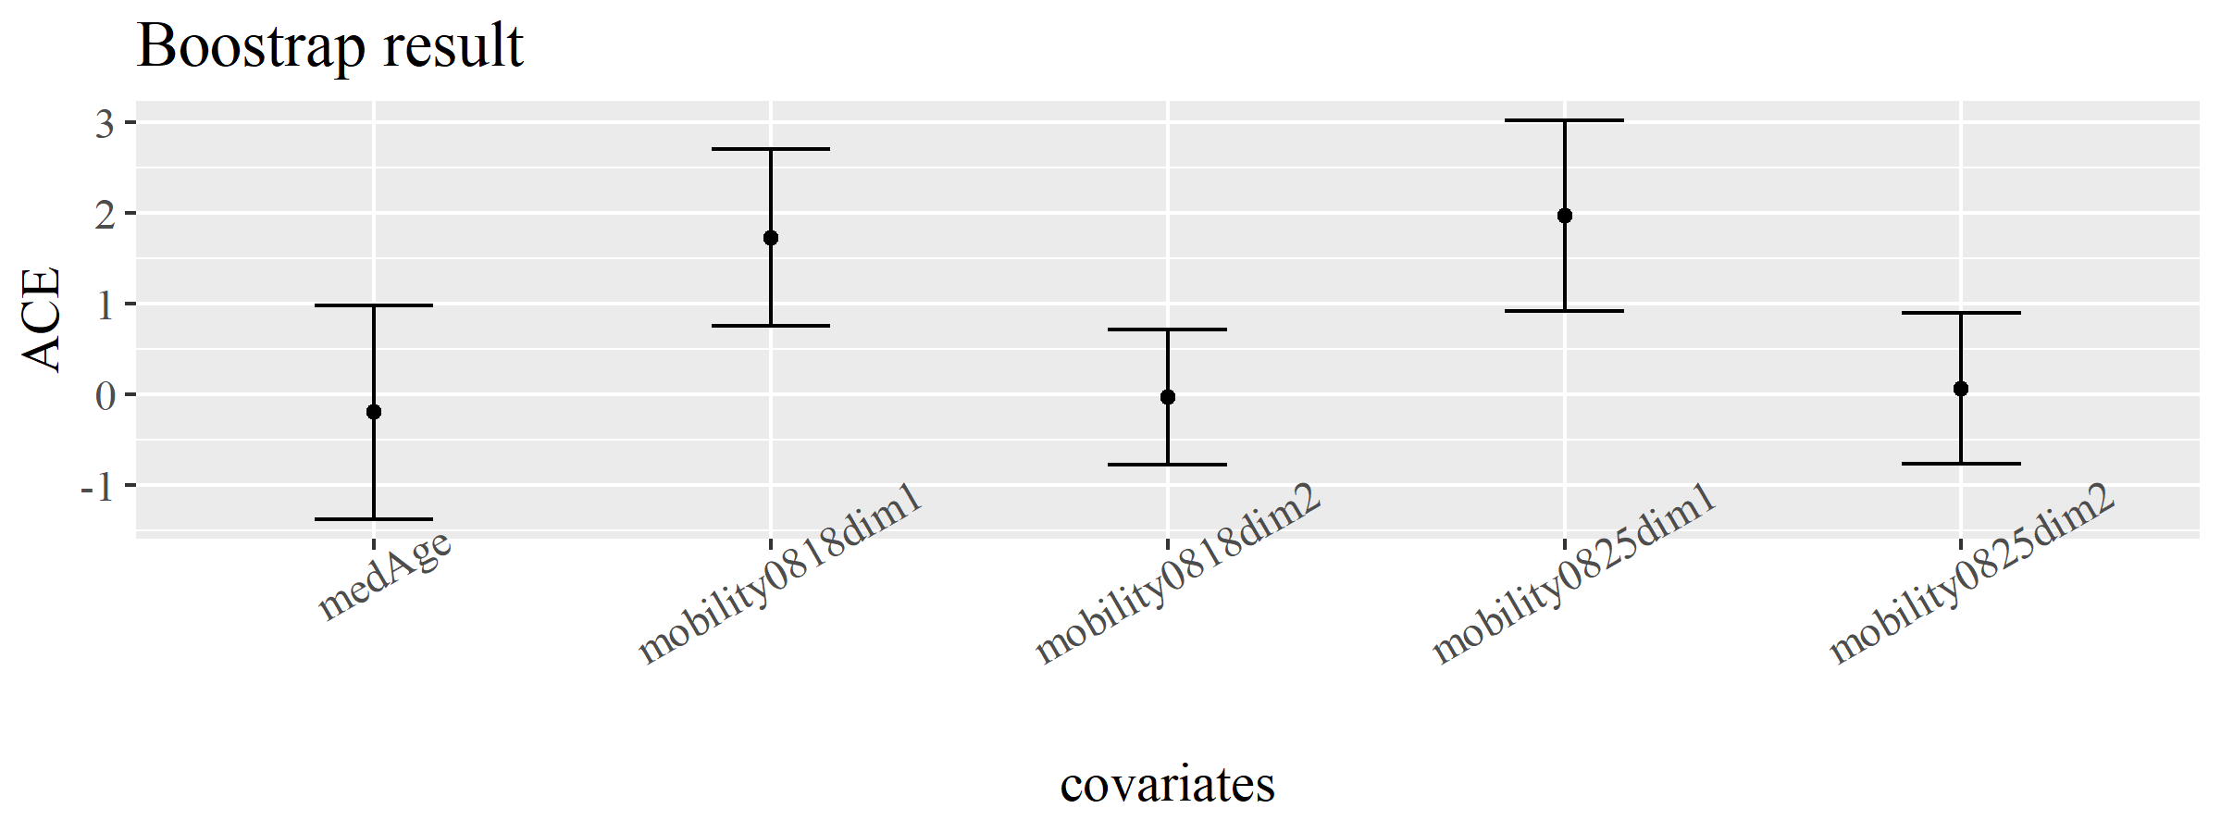

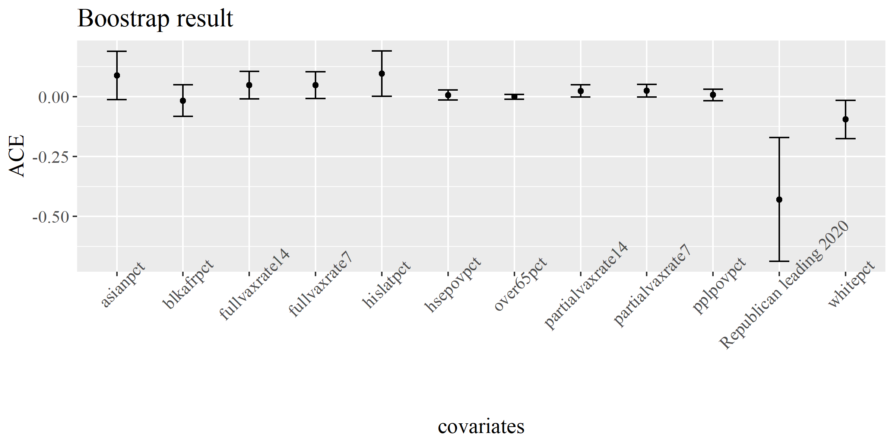

Figure 2 Balance check: point estimates and 95% confidence intervals of the average causal effect on covariates

The difference-in-means is calculated using Hajek estimator. It’s invariant to the location transformation, and moreover, much more stable than the Horvitz-Thompson (HT) estimator in finite samples according to many numerical studies (12).

${\hat{τ}}_{hajek}=\frac{\sum_{i=1}^{n}{\frac{Z_{i}Y_{i}}{\hat{e}(X_{i})}}}{\sum_{i=1}^{n}{\frac{Z_{i}}{\hat{e}(X_{i})}}}-\frac{\sum_{i=1}^{n}{\frac{{(1-Z}_{i})Y_{i}}{1-\hat{e}(X_{i})}}}{\sum_{i=1}^{n}{\frac{{1-Z}_{i}}{1-\hat{e}(X_{i})}}}$

To account for the randomness of random forest, we run the algorithm 1000 times and report the mean estimated average causal effect. The results for these two different lower bounds are similar as shown in **Figure 3**. ACE with $α_{L}=0.05$ is $-1.03*{10}^{-3}$ with a asymptotic 95% confidence interval [$-1.50*{10}^{-3}, -5.87*{10}^{-4}$]; whereas ACE with $α_{L}=0.001$ is $-1.04*{10}^{-3}$ with a asymptotic 95% confidence interval [].

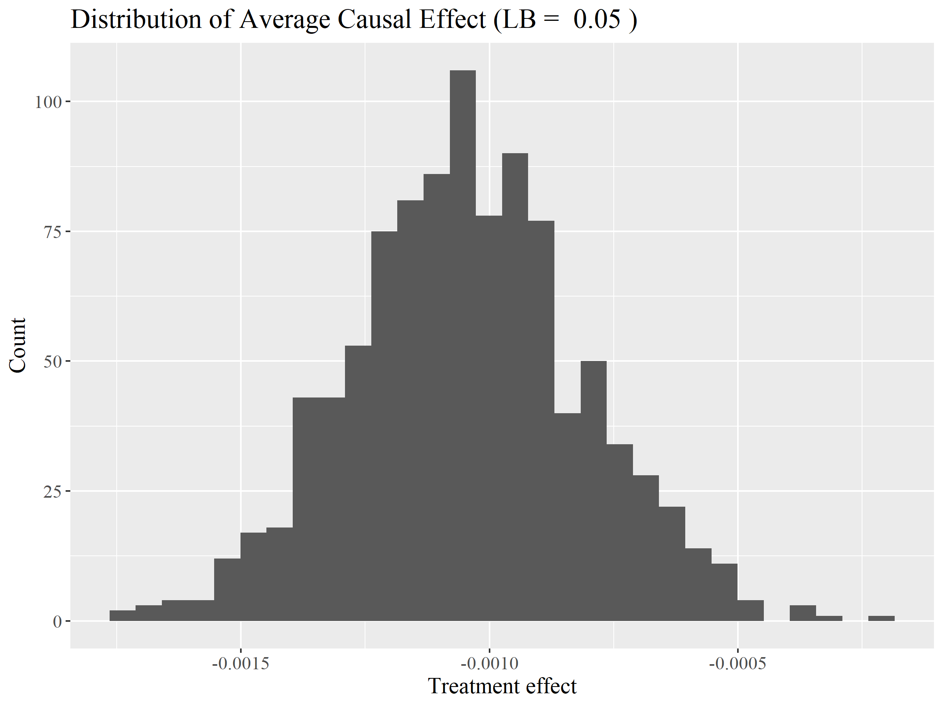

Figure 3 Distribution of estimated treatment effect with different lower bound truncation for propensity score

We bootstrapped the sample 500 times to generate the distribution of estimated ACE (**Figure 4**). The mean ACE is $-4.20*{10}^{-3}$ with standard error $3.79*{10}^{-3}$.

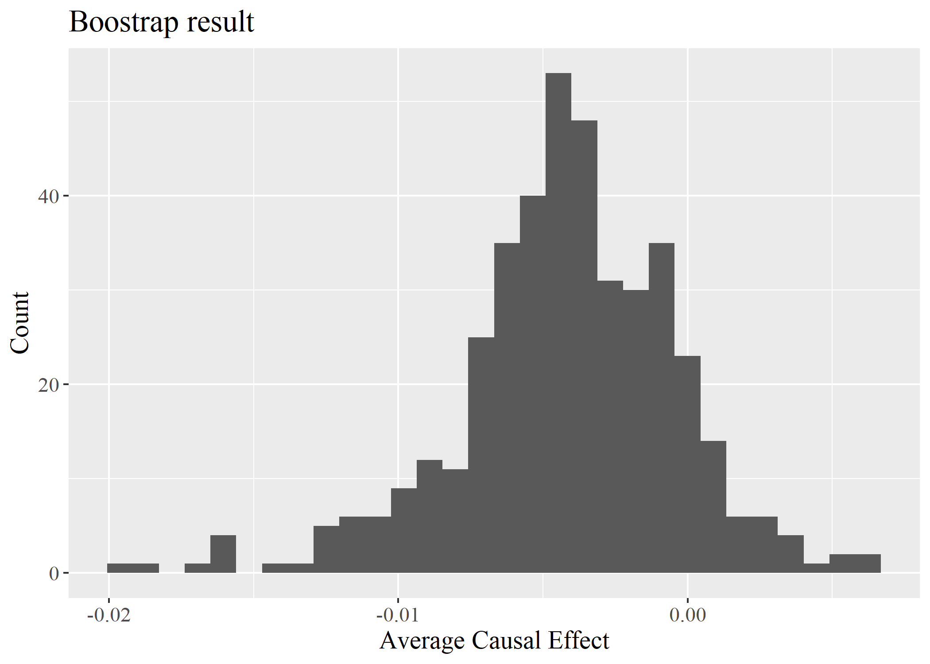

Figure 4 Distribution of ACE with bootstrap N = 500

## Doubly Robust Estimator

Here we combine the outcome and propensity score model mentioned above to construct a doubly robust estimator for ACE. The combination is consistent if either the propensity score or the outcome model is correctly specified. The ACE is estimated as below,

$$\hat{τ}={\hat{μ}}_{1}^{dr}-{\hat{μ}}_{0}^{dr}$$

$${\hat{μ}}_{1}^{dr}= \frac{1}{n}\sum_{i=1}^{n}{[\frac{Z_{i}\left\{Y_{i}-μ_{1}\left(X_{i}, {\hat{β}}_{1}\right)\right\}}{e\left(X_{i},\hat{α}\right)}+μ_{1}(X_{i}, {\hat{β}}_{1}]}$$

$${\hat{μ}}_{0}^{dr}= \frac{1}{n}\sum_{i=1}^{n}{[\frac{{(1-Z}_{i})\left\{Y_{i}-μ_{0}\left(X_{i}, {\hat{β}}_{0}\right)\right\}}{1-e\left(X_{i},\hat{α}\right)}+μ_{0}(X_{i}, {\hat{β}}_{0}]}$$

For outcome model, we continue to use the linear model estimated in the first session and assume no differences in outcome model between treatment and control group (i.e. ${\hat{β}}_{1}= {\hat{β}}_{0}$). The propensity score for each data points is estimated by running random forest 1000 times and taking average of the estimated score (with lower bound 0.05) across all the runs. We bootstrapped the sample 500 times to generate the distribution of estimated ACE. The mean ACE is $-3.27*{10}^{-3}$ with standard error $-1.28*{10}^{-2}$.

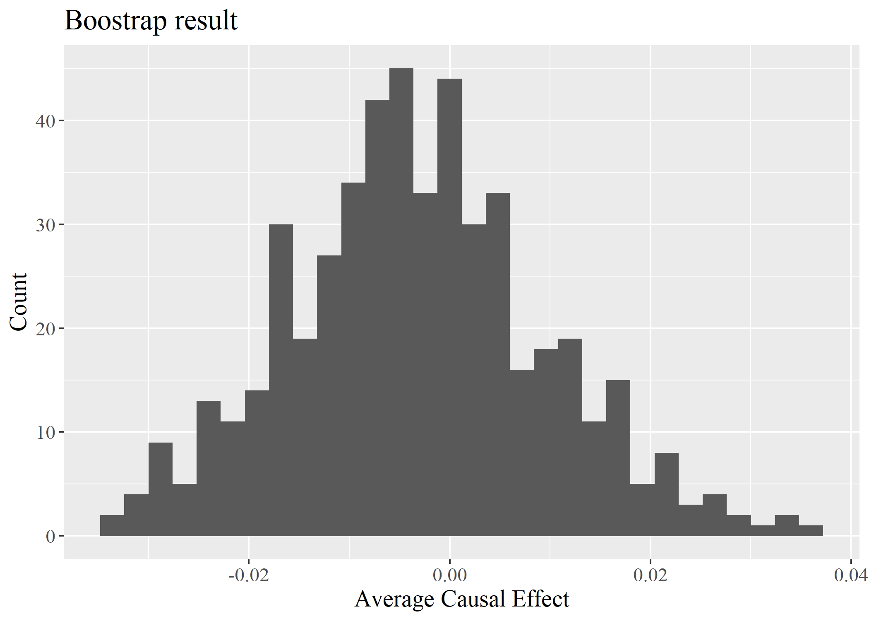

Figure 5 Distribution of ACE with bootstrap N = 500

## Comparison of Results

**Table 4** compares the results across three approaches. The estimated average causal effect is consistently negative for all three methods. Linear regression produced the greatest reduction of 0.987% reduction in confirmed case growth rate 14 days after the target day whereas Hajek estimates produced the lowest reduction of 0.420% while that for doubly robust estimate is 0.537%. Assuming gaussian distribution, the estimated ACE from outcome regression and Hajek are both not significantly less than zero at p < 0.1. Whereas doubly robust estimate shows an over 90% chance that implementing mask mandate at least for the non-vaccinated will reduce the CIVD-19 confirmed case growth rate 14 days after the target date.

Table 4 ACE and standard error by approach

|  |  |  |  |
| --- | --- | --- | --- |
|  | **Linear** | **Hajek** | **Doubly Robust** |
| **Est.** | -0.00987 | -0.00420 | -0.00537 |
| **s.e.** | 0.00972 | 0.00379 | 0.00406 |
| **95% CI** | [-0.0289,0.00918] | [-0.0116, 0.00323] | [-0.0298, 0.0204] |
| **One-tailed P-Value** | 0.155 | 0.134 | 0.093 |

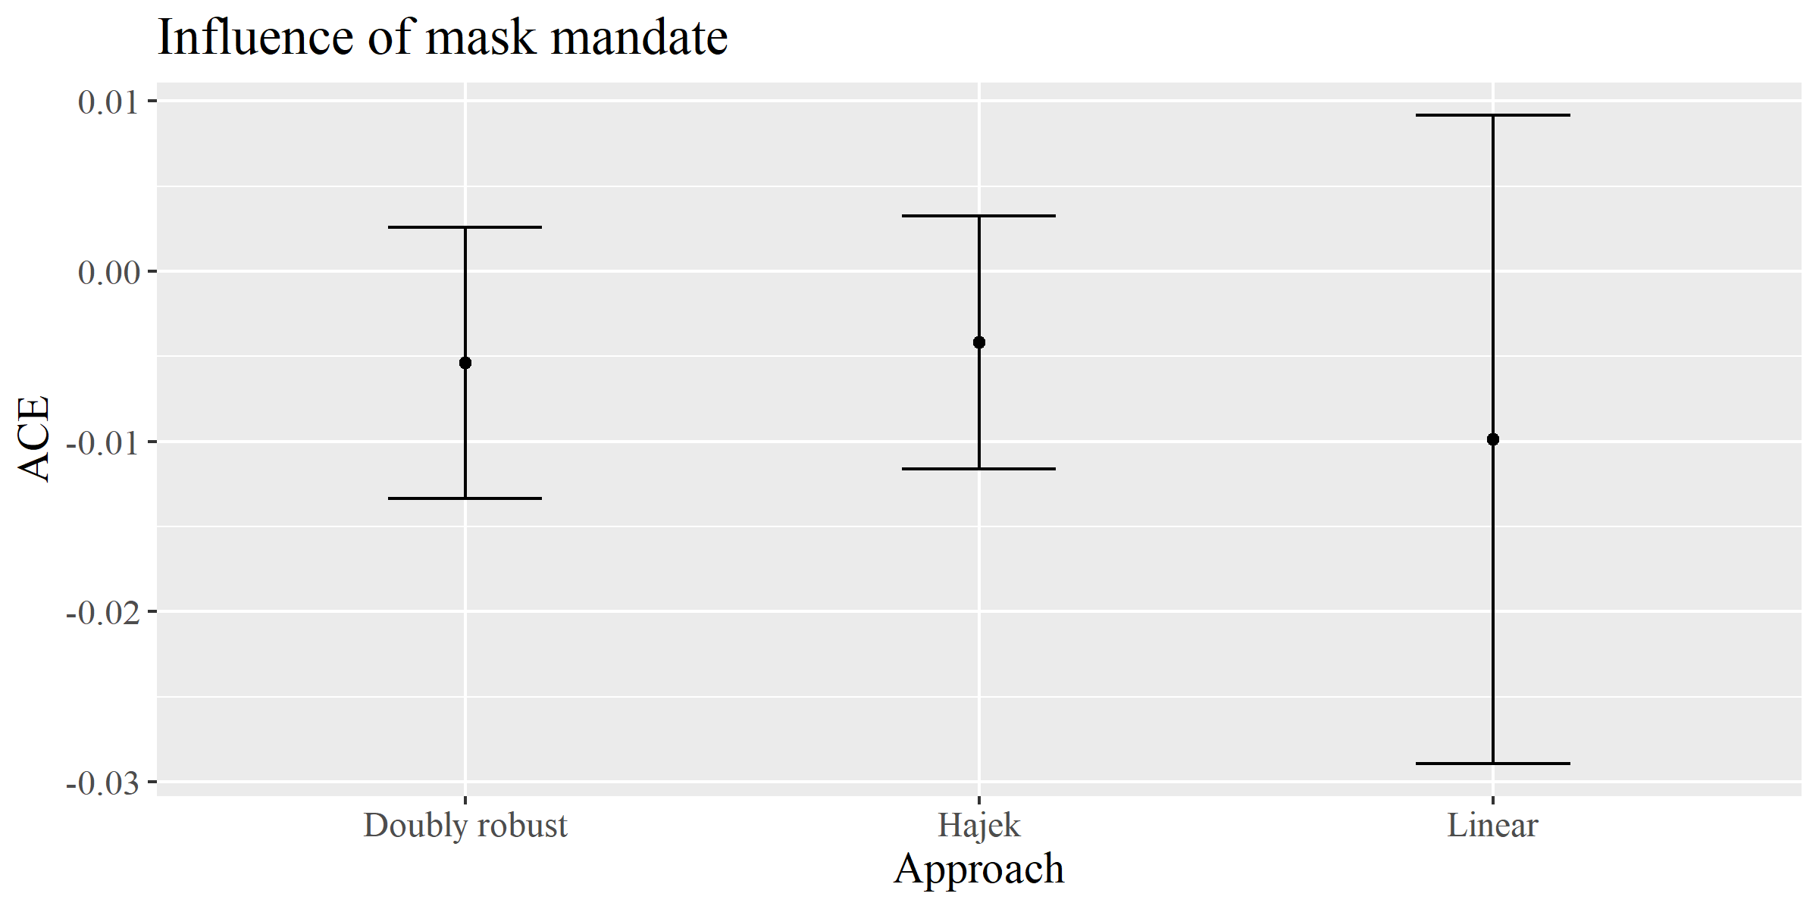

Figure 6 Estimated effect on growth rate 14 days after by approach

We also try to examine the effect of mask mandate implementation as time goes by. As doubly robust approach is more resistant to model misspecification, we apply it to estimate the impact mask mandate on the growth rate {7, 14, 30} days after September 1, 2021. The difference between treatment and control group growth as time goes by. 7 days after the target date, a state with mask mandate is expected to have growth rate of 1.026 while a state without mask mandate is expected to have a growth rate of 1.029, though the difference is not significant with p < 0.1. Two weeks after the target date, the expected growth rate for treatment group 1.054 while that for control group is 1.060 and they are significantly different with p < 0.1. After 30 days, the expected growth rate for treatment group 1.114 while that for control group is 1.124. The outcome is not significantly different with p < 0.1. 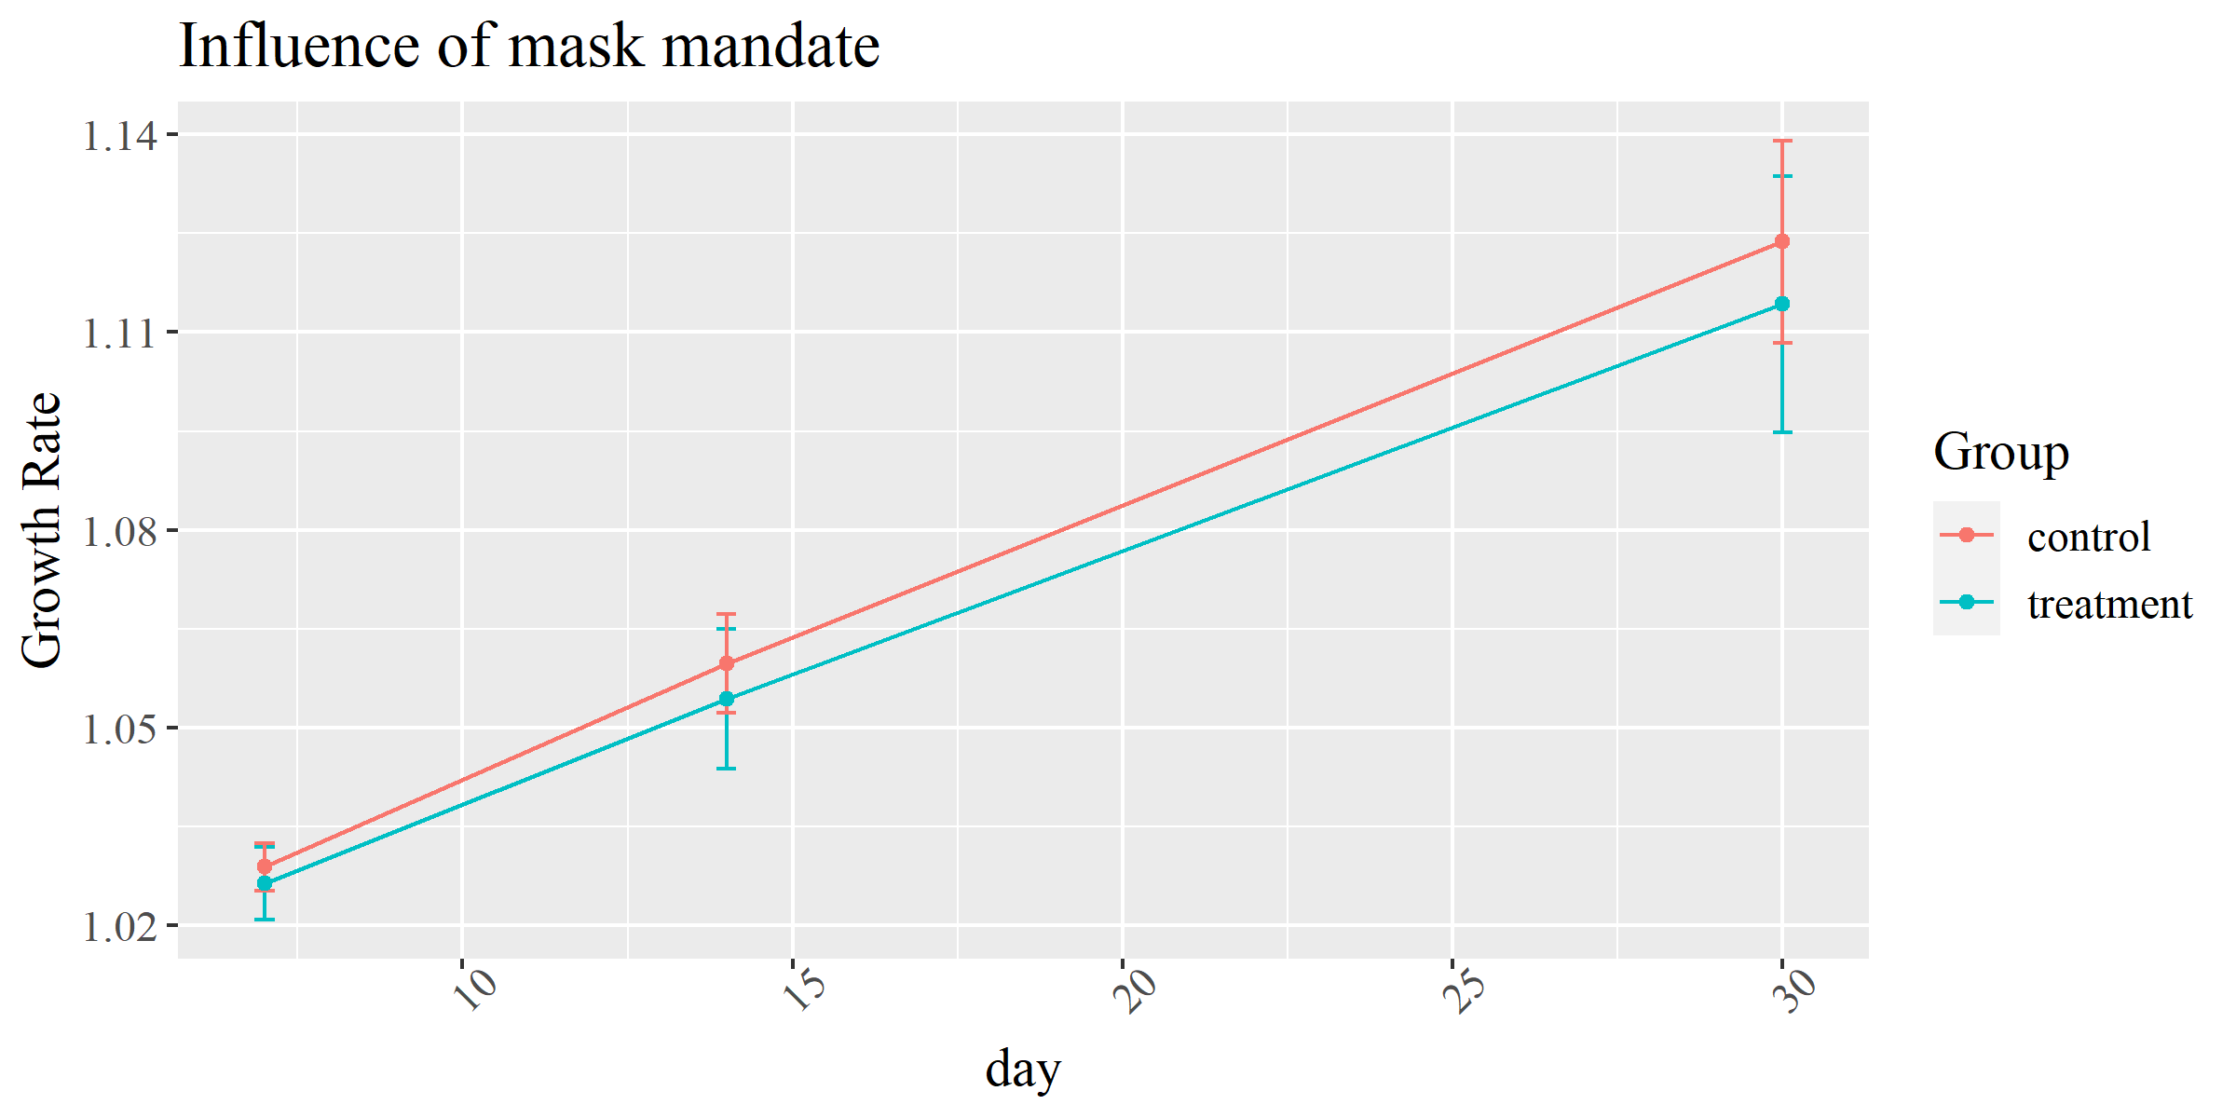

Figure 7 Confirmed case growth rate N days after by treatment

Figure 8 Estimated effect on growth rate N day after September 1, 2021

Table 5 Difference in confirmed case growth rate

|  |  |  |  |  |
| --- | --- | --- | --- | --- |
| **Delay** | **Treatment (95%CI)** | **Control (95% CI)** | **ACE (95% CI)** | **ACE One -tailed P-value** |
| **7 days** | 1.026 (1.021, 1.032) | 1.029 (1.205, 1.032) | -0.002 (-0.007, 0.002) | 0.138 |
| **14 days** | 1.054 (1.044, 1.065) | 1.060 (1.052, 1.067) | -0.005 (-0.013, 0.003) | 0.093 |
| **30 days** | 1.114 (1.095, 1.134) | 1.124 (1.108, 1.139) | -0.009 (-0.024, 0.005) | 0.105 |

# DISCUSSION

As students started to return to campus, daily travel and activity frequency gets higher and closer to the level before the pandemic. Increased exposure risk and transmission probability, coupled with the enhanced spread ability of new virus variant, again pose great threat to public health. The loosened statewide pandemic restrictions like indoor capacity limits and mask mandate might not be able to accommodate current situation. Reevaluation of public health policy is critical to see whether the previous relaxation is still valid at a point when schools reopen, and a statewide mobility change is observed.

The study aims to exam the effectiveness of mask mandate on public health outcomes. Specifically, we want to see if having a public mask mandate implemented at least for the non-vaccinated can suppress the COVID confirmed case growth rate. The analysis is conducted at the state level with the development of a causal inference framework. Here, the treatment is whether a state have implemented a mask mandate at least for the non-vaccinated by September 1, 2021, when most of the students have returned to campus; the outcome is the confirmed case growth rate 7, 14, 30 days after the target date. Confounders including population demographic, population density, political leading, previous COVID status and mobility change are considered. Three approaches including outcome regression, propensity score weighting and doubly robust are adopted to estimate the average causal effect. All three methods show a negative ACE and thus a reduction effect of mask mandate on confirmed case growth rate 14 days after the target date, among which, doubly robust estimates a significant reduction impact with p < 0.1. We further apply doubly robust estimates to see the effect of mask mandate as time goes by. A long-term impact of mask mandate implementation is found that the difference in expected confirmed case growth rate between treatment and control group increase. The result further confirms the critical role of mask mandate in the battle with pandemic.

However, there are some limitations in this study that can be further addressed. First, as the covariate balance check shows, the covariates are not well balanced across treatment and control group, which means the violation of ignorability assumption and thus the biasedness of our estimates. Future study can collect other variables in order to capture those unmeasured confounders. Sensitivity analysis can also be conducted to assess the influence of unmeasured confounders on causal conclusions (13). Second, we only focus on two levels of treatment in this study (ie. whether implement a mask mandate at least for the non-vaccinated or not). However, the strictness of mask mandate policy is multilevel instead of a binary treatment. In between of mandate versus no mandate, there are states recommend but not require masking in public space. Further, under the umbrella of statewide policy, there’re also county variations. As the belief of whether government should interfere personal freedom of mask wearing varies, a relative strict policy might lead to defiance and thus actually less effective than a soft recommendation. Therefore, the effectiveness of mask policy with different strictness level is also worth examining and could provide valuable insight for future policy decision making.

# REFERENCE

1. first-and-second-waves-of-coronavirus @ www.hopkinsmedicine.org [Internet]. Available from: https://www.hopkinsmedicine.org/health/conditions-and-diseases/coronavirus/first-and-second-waves-of-coronavirus

2. Brainard J, Jones NR, Lake IR, Hooper L, Hunter PR. Community use of face masks and similar barriers to prevent respiratory illness such as COVID-19: A rapid scoping review. Eurosurveillance. 2020;25(49).

3. Chernozhukov V, Kasahara H, Schrimpf P. Causal impact of masks, policies, behavior on early covid-19 pandemic in the U.S. J Econom [Internet]. 2021;220(1):23–62. Available from: https://doi.org/10.1016/j.jeconom.2020.09.003

4. Wong AK. Evaluating Public Masking Mandates on COVID-19 Growth Rates in U . S . States. 2021.

5. COVID-19 Recommendations for Older Adults [Internet]. Available from: https://www.cdc.gov/aging/covid19/covid19-older-adults.html

6. COVID-19 Cases and Deaths by Race/Ethnicity: Current Data and Changes Over Time [Internet]. Available from: https://www.kff.org/racial-equity-and-health-policy/issue-brief/covid-19-cases-and-deaths-by-race-ethnicity-current-data-and-changes-over-time/

7. Hopkins J. coronavirus resource center [Internet]. Available from: https://coronavirus.jhu.edu/about/how-to-use-our-data

8. Raifman J, Nocka K, Jones D, Bor J, Lipson S, Jay J and CP. COVID-19 US state policy database (CUSP) [Internet]. 2020. Available from: https://docs.google.com/document/d/1x4L4eJix6GTFqR-pFnX67xbdyHl5tVJHPwYbTPfascs/edit

9. New York Times. Presidential Election Results [Internet]. Available from: https://www.nytimes.com/interactive/2020/11/03/us/elections/results-president.html

10. Google. Community Mobility Reports [Internet]. Available from: https://www.google.com/covid19/mobility/

11. Kurth T, Walker AM, Glynn RJ, Chan KA, Gaziano JM, Berger K, et al. Results of multivariable logistic regression, propensity matching, propensity adjustment, and propensity-based weighting under conditions of nonuniform effect. Am J Epidemiol. 2006;163(3):262–70.

12. Ding P. A First Course in Causal Inference.

13. Dinga P, VanderWeele TJ. Sensitivity analysis without assumptions. Epidemiology. 2016;27(3):368–77.